**Model Development Phase Template**

|  |  |
| --- | --- |
| Date | 15 June 2024 |
| Team ID | 739820 |
| Project Title | Predicting the unpredictable: A  Look into the World of Powerlifting |
| Maximum Marks | 4 Marks |

**Initial Model Training Code, Model Validation and Evaluation Report**

The initial model training code will be showcased in the future through a screenshot. The model validation and evaluation report will include classification reports, accuracy, and confusion matrices for multiple models, presented through respective screenshots.

**Initial Model Training Code:**

#importing and building the linear regression model:

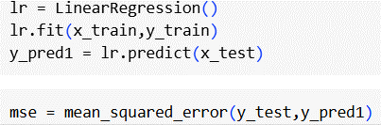



#importing and building the RandomRegression model:

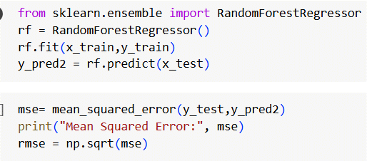

#importing and building DecisionTree Model:

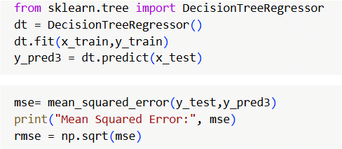

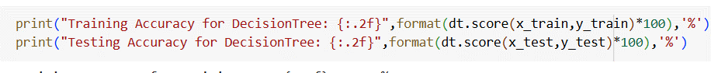

#importing and building the XGboost Model:

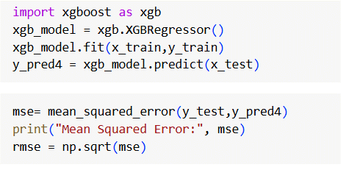





|  |  |  |  |
| --- | --- | --- | --- |
| **Model** | **RMSE** | **F1 score** | **Accuracy** |
| Linear regression | 21.814068813999864 | | 21.814068813999864 | | Training Accuracy:  79.55925360084694  Testing Accuracy:| 79.95753541725657 |

**Model Validation and Evaluation Report:**

|  |  |  |  |
| --- | --- | --- | --- |
| Random forest | 21.814068813999864 | 21.814068813999864 | | Training Accuracy:  98.32882732596175  Testing Accuracy:  87.81981945246893 | |
| Decision  Tree | 21.814068813999864 | | 21.814068813999864 | | Training Accuracy:  100.0  Testing Accuracy:  77.16769363515307 |
| XGBoost | 21.814068813999864 | | 21.814068813999864 | | Training Accuracy:  94.51461911481135  Testing Accuracy:  87.72510461710547 |